EXPERIMENT 2

REDESIGN CANTEEN MENU TO INCREASE THE EASE OF USE AND EASE OF FUNCTIONALITY

AIM:

To redesign canteen menu to increase the ease of use and ease of functionality

PROCEDURE:

\* Create a wireframe according to the mobile application

\* Decide the name an select the theme

\*Create a login page with the essential details and app name

\*Create multiple wireframes according to the need

\*Create the menu page which contains offer,discount,cuisines etc

\*Create detailed list of any variety

\*At last make a page of confirmed order which shows a series from login to confirmation of order

SCREENSHOT:

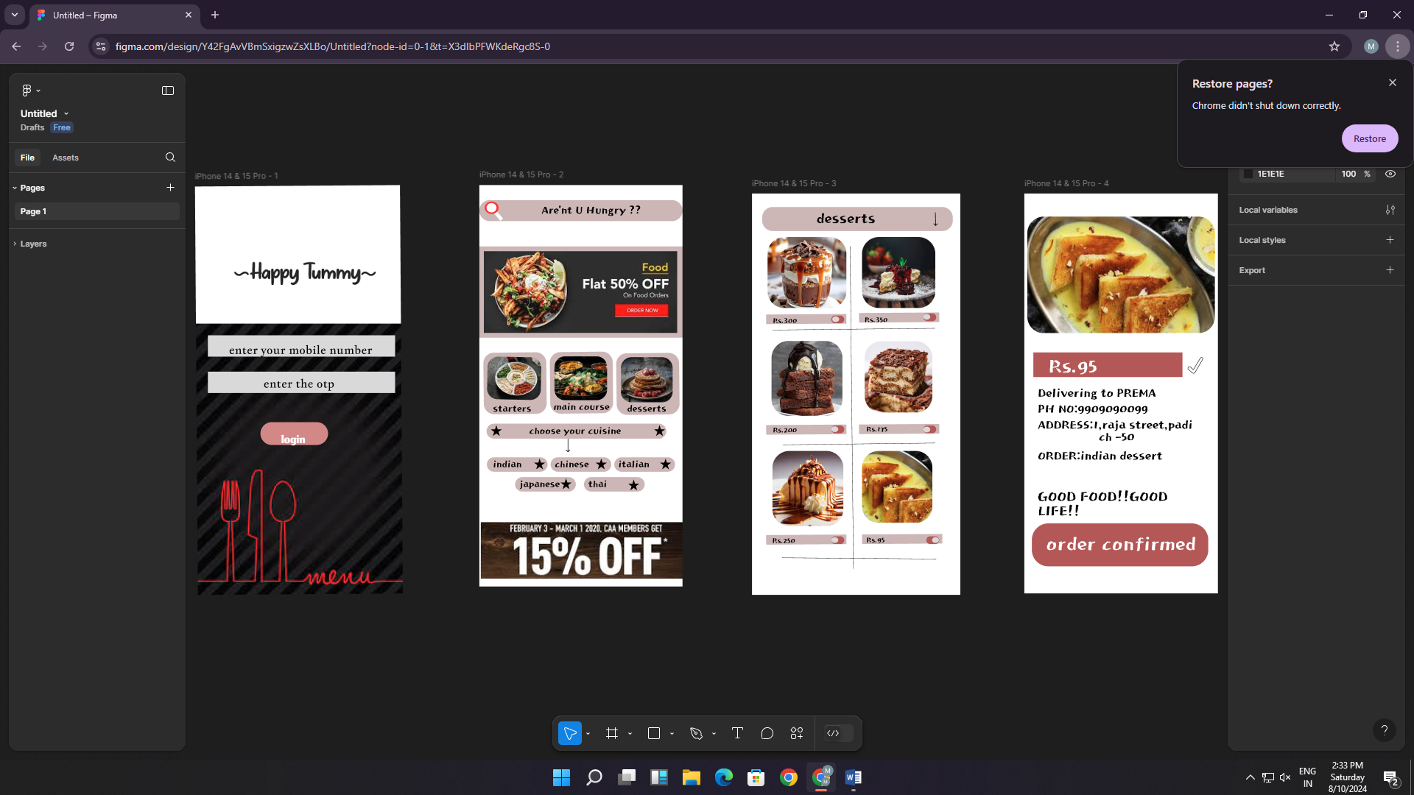

RESULT:

Canteen menu to increase the ease of use and ease of functionality is designed